
Org Mapping IR Data Guide

The purpose of this document is to provide an overview of org mapping as it relates to reporting and analytics provided by IU Institutional Analytics. While originally derived from the university's HR and financial systems, the org map does not change departmental budgets. It is simply a critical reporting mechanism which allows data to be reported in a way that is consistent and provides the most opportunity for greater flexibility and usability.
An example of the current org hierarchy discussed below can be found here.

What is Org Hierarchy?

Org hierarchy is derived from the chart of accounts (COA) in Indiana University’s HR and Financial systems, known as HRMS and KFS, respectively. The COA is a set of tables that define coding structures for accounts, organizations, responsibility centers (RCs), etc. at IU, providing a foundation for summarizing and reporting data across the university. This structure forms a hierarchy, allowing granular units to be rolled up into higher levels of aggregation, and larger entities to be disaggregated into smaller units.

The highest level of the hierarchy represents the university, which then branches out into campus, RC, and further org/sub-org levels (e.g., division, department, sub-department). The RC level manages both administrative control and ownership of resources. For Bloomington and Indianapolis, RCs are generally equivalent to academic schools, like the School of Education or the School of Public Health. Responsibility centers at the regional campuses tend to be administrative units that have oversight over one or more schools (see Table 1).

There is no corresponding hierarchy in the Student Information System (SIS). There is an entity called an academic group, which is comparable to school. Academic groups are, however, not hierarchical, not easily changed, and do not correlate very well with financial responsibility centers.

Table 1: Academic schools are sometimes represented at different levels in the org hierarchy. This shows examples of academic schools being represented at the RC and departmental levels for the Indianapolis and South Bend campuses, respectively.
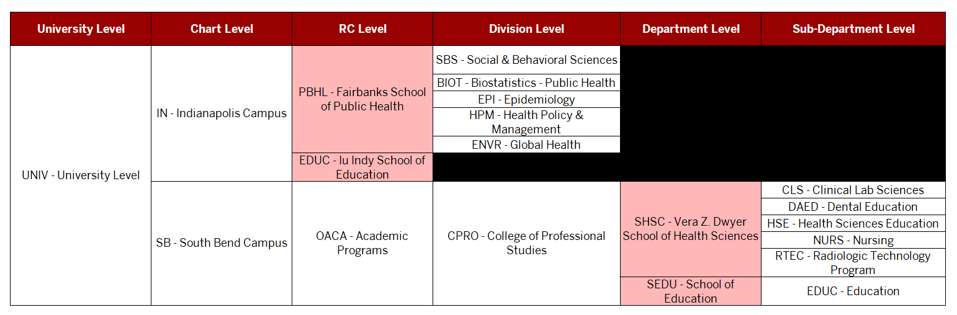
What is Org Mapping?

In 2016, with the advent of the Decision Support Initiative, which sought to combine Financial, HR, and Student data together, it became necessary to correlate orgs in KFS/HR hierarchy to student data. There is also a growing need by leadership and legislature to show return on investment (ROI) and student outcomes at the program level.

Students can have up to three plans recorded for them upon degree completion or in each academic term of enrollment. Most plans have been mapped to a financial org. This way, we can say students with a given plan “belong to” a particular org. To get the most useful categorization, plans, which are specific to students’ program of study, should be mapped to the most granular corresponding org feasible. Table 2 shows examples of plans being mapped as the most granular at the sub-department level (Biotechnology BS) to less granular at the department level (Earth Science BS and Microbiology BS) to even less granular at the division level (Computer Science BA and Environ & Sustainability BA). These differences pose challenges for reporting data at consistent levels of granularity. Also displayed in table 2, the org map allows for preparatory plans to be mapped to the same hierartracking and reporting intended school/RC.

Table 2. Plans should be mapped at the most granular org feasible for most useful categorization. This shows examples of plans being mapped at the most granular level at sub-department (Biotechnology BS) to less granular levels such as division (Computer Science BA and Environ & Sustainability BA). Preparatory plans can be mapped to the same hierarchy as their major counterparts, facilitating tracking by intended school/RC.

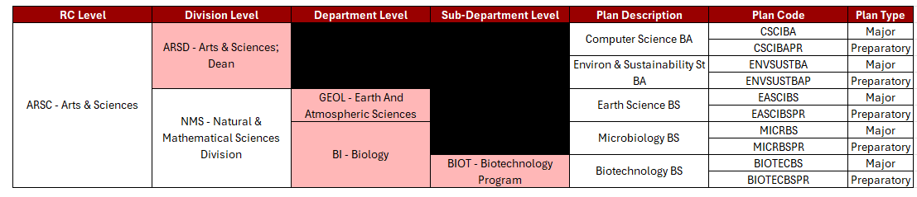
Similarly, courses have a single subject. Most subjects have been mapped to a financial org (e.g. ENG-W131 with subject code ENG-W is mapped to EA-HSS which represents the Humanities and Social Science org on the East campus). This way, we can say courses with a given subject “belong to” that org.

How is Org Mapping maintained in SIS?
On the SIS plan table PS_ACAD_PLAN, two columns have been added to specify the unique org (chart and org) for that plan. The Chart code is a two-character code which originates in the COA, which designates an individual campus (e.g. BL for Bloomington). These are readily available in the data warehouse from the table DSS_SH.SH_ACAD_PLAN_DM.

On the SIS subject table PS_SUBJECT_TBL, two columns have been added to specify the unique org (chart and org) for that subject. These are readily available in the data warehouse from the table DSS_SH.SH_SR_CRS_SUBJ_INST_DM .

For convenience, we have created database views in the data warehouse that combine org mapping and org hierarchy together, ready to join to your data source. The plan view is called DSS_RDS.IR_STU_PLN_FIN_ORG_HIER_V, with primary keys/granularity being defined by campus (INST_CD) and plan (ACAD_PLAN_CD).The subject view is DSS_RDS.IR_CRS_SUBJ_FIN_ORG_HIER_V.

How is Org Mapping surfaced in Tableau?

Tableau reports are an ideal medium for org mapping. When org mapping has been joined to the underlying data, it is possible to subtotal measures by elements of the org hierarchy. One common application (in EBI/AM360 workbooks) is to use Responsibility Center (RC_CD_AND_DESC) and Department (COMB_DEPT_LVL_DESC) as filters.

Another application is to subtotal large populations by dimensions in the org hierarchy. In the Official Enrollment tableau, screenshot below, each level has been added as an Attribute. Selecting “School”, “Division”, and “Department” as the three Attributes shows the hierarchical nature of the dimensions. In the snapshot below, 60 students with plans that have been mapped to Department “Art History” have enrolled in Fall 2025.

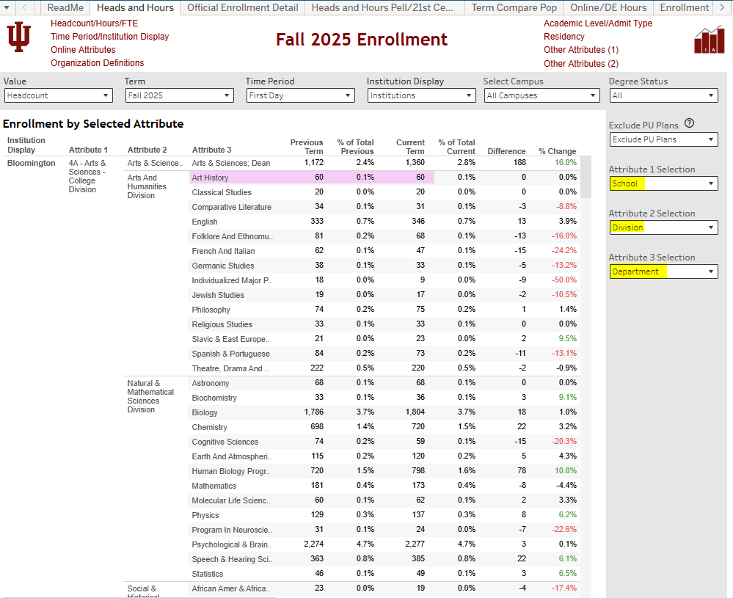

Historically, the SIS dimension Academic Group has been used as a proxy for “School”. As mentioned earlier, academic groups are not an accurate representation of School, so as org mapping is being added to existing tableau reports, if the academic group dimension is going to be retained in the workbook, best practice would be to revert the label back to academic group, reserving “School” for the responsibility center obtained from org mapping.

A Deep Dive into Orgs and RCs: Some Unique Campus Considerations
How are Schools that are not RCs represented in Org Hierarchy?

UNIV is the top org in KFS. It is the only org that does not have a parent. There are 10 orgs whose parents are UNIV. Generally, these are each campus plus University Administration. We have named these level 2 orgs.

Similarly, the orgs whose parent is a level 2 org are locally known as level 3 orgs. These level 3 orgs are frequently responsibility centers, but not always. Responsibility Centers are generally large orgs that have administrative and budgetary resources and responsibility. There is a Y/N field on the org table indicating whether a given org is a responsibility center or not. It does not have to be a level 3 org either; at East, the RCs are level 4. Responsibility Centers at Bloomington and Indianapolis tend to be Schools, like the Law School or Business School. RCs at regional campuses tend to be administrative units that have oversight over one or more schools.

Also on the org table, there is a field called RC_CD. This is a two-character alpha-numeric field. Examples are 4B and 24. If we concatenate the RC_CD and the ORG_NM of an org marked as an RC, we get RC_CD_AND_DESC, for example 4B – MEDIA SCHOOL or 24 – BUSINESS. South Bend has one (academic) RC: 52 – ACADEMIC PROGRAMS.

Children of level 3 orgs are level 4 orgs. If the level 3 org was an RC, then the level 4 org might be called a Division. Following the pattern, level 5 orgs are labeled Departments and level 6 orgs are Sub-Departments. The associative power of these labels diminishes with each additional level, because they mean different things on different campuses.

There are a few outliers that don’t fit the level 3 = RC assumption. For East, the RC_CD_AND_DESC is the same as the Division, because the RC is a level 4 org. Kokomo has a mix of RCs at level 3 and level 4. At South Bend, the single RC is level 3, but RC is an administrative unit, and the schools are at level 4. Columbus campus is a single RC on the IN chart, and their schools are level 4 orgs.

There are a couple of (Bloomington) cases where, via hardcoding an exception in the org hierarchy build logic, a non-RC org has been “promoted” to an RC, thereby shifting all subordinate orgs up one level. For example, Nursing is a child of RC 52 – Other Academic Programs, but it appears in org hierarchy as 52 – Nursing. We could apply that same technique to other outliers if stakeholders deemed it appropriate.

In order to accommodate these exceptions, we have built an RC override table which lists orgs that should be rendered in the hierarchy at the top level, even though they are not marked as RCs in KFS. These exceptions are typically academic schools. This way, for example, Bloomington Nursing, which is not an RC, can be promoted to appear as an RC in the org hierarchy. This also allows schools at regional campuses, which are not necessarily RCs in KFS, to fit the pattern of School > Division > Department > Sub-Department. In order to distinguish between actual KFS Responsibility Centers and this adaptation to make academic schools appear as RCs, in Tableau reports that use this feature, the top org will be called “School”.

As of 11/24/2025, these are the orgs that are being presented in org hierarchy as School even though they are not RCs in KFS:

FIN_COA_CD | ORG_CD | ORG_NM
BL | AERO | AEROSPACE STUDIES
BL | MILS | MILITARY SCIENCE
BL | NURS | NURSING
BL | SOCW | SOCIAL WORK
BL | LBST | LABOR STUDIES
IN | CBUS | IU COL BUSINESS
IN | CDHS | IU COL HEALTH SCIENCES
IN | CEDU | IU COL EDUCATION
IN | CLAR | IU COL LIBERAL ARTS
IN | CMEG | IUPUC MECHANICAL ENGINEERING
IN | CNUR | IU COL NURSING
IN | CSCN | IU COL SCIENCE
IN | CUNC | IU COL UNIVERSITY COLLEGE
SB | ARSC | COLLEGE OF LIBERAL ARTS & SCIENCES
SB | BUS | BUSINESS AND ECONOMICS
SB | CHS | VERA Z. DYWER COLLEGE OF HEALTH SCIENCES
SB | REGR | REGISTRAR
SB | LBST | LABOR STUDIES
SB | SOCW | SOCIAL WORK
SB | SART | RACLIN SCHOOL OF THE ARTS
SB | SHSS | SCHOOL OF HUMANITIES & SOCIAL SCIENCES
SB | SNSC | SCHOOL OF NATURAL SCIENCES
SB | SBUS | JUDD LEIGHTON SCHOOL OF BUSINESS & ECONO
SB | SEDU | SCHOOL OF EDUCATION
SB | SHSC | VERA Z. DWYER SCHOOL OF HEALTH SCIENCES

Of note, direct admits can be included/excluded from reports and analysis using direct admit fields available (e.g., ACAD_PRM_PGM_ADMTD in dss_rds.ir_cen_trm_snpsht_st)

